Teapot Hierarchy
Eva Nolan
14335443

Root Teapot
The project presented consists of five teapots in a design based our solar system. The root teapot acts as “the sun” about which all the other teapots rotate.
As the root of the hierarchy it is oriented in global space.
It is translated upwards when the “x” key is pressed. When it is translated all of the other teapots undergo an equal transformation
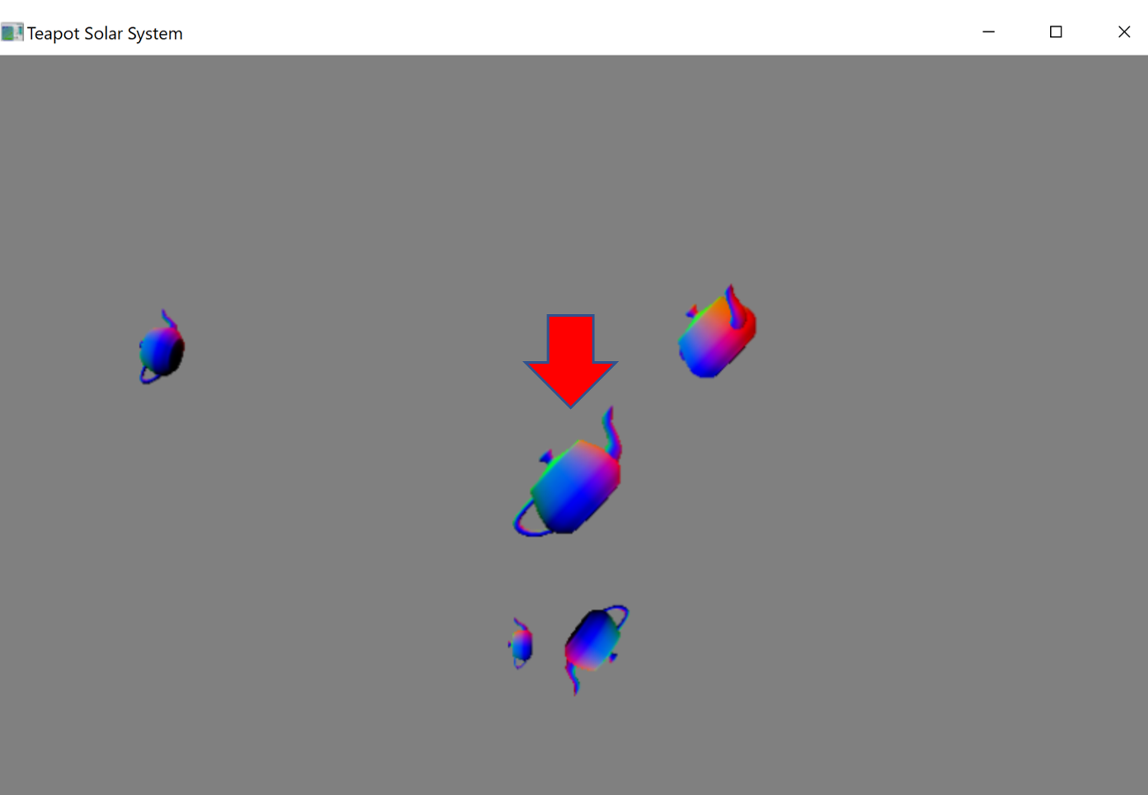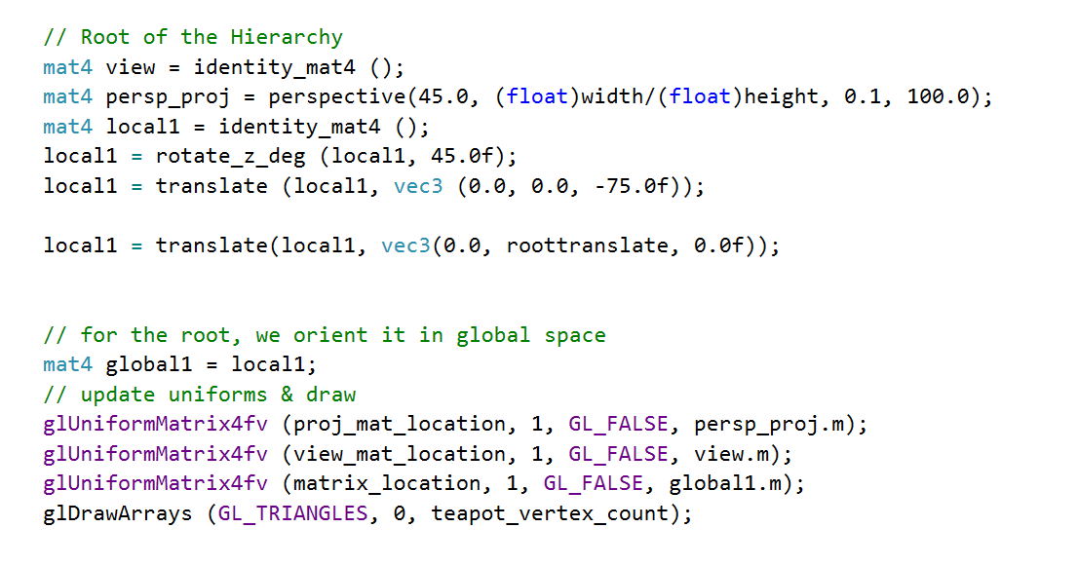

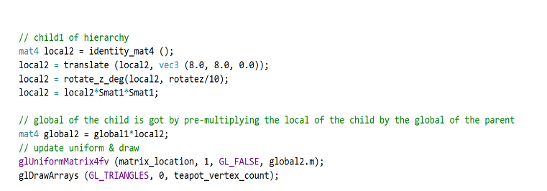
Teapot Number Two
Teapot number two rotates about the x axis of the root. This is achieved by translating away from the root before rotating about its axis
As a child of the root its global is gotten by multiplying its local by the global of the root.
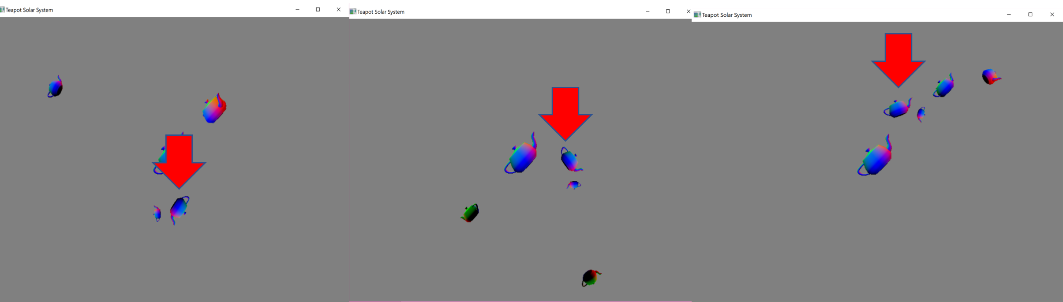
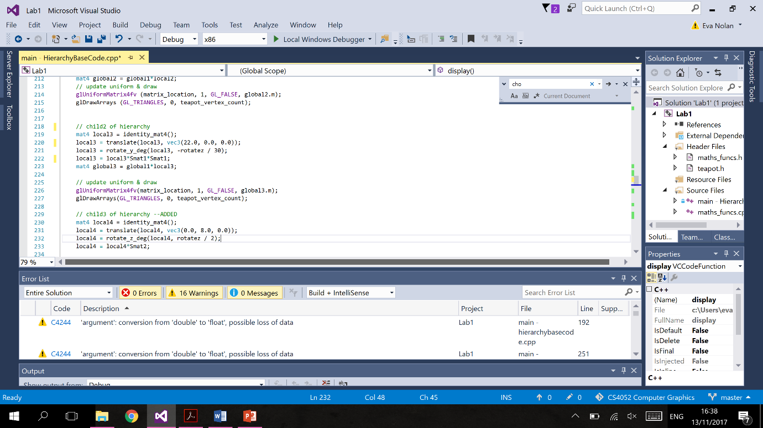
Teapot Number Three
Teapot number three rotates about the y axis of the root. It passes in front of and behind the root as it rotates giving the overall structure more of an interesting 3D effect.

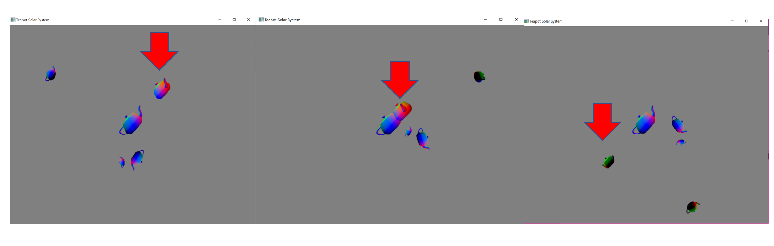

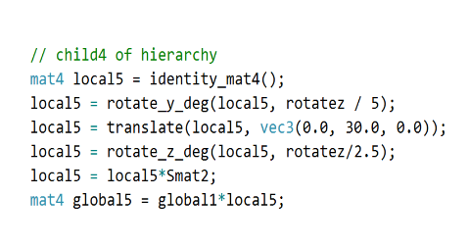
Teapot Number Four
Teapot number four takes the widest rotation about the root. It also rotates about its own y axis. This is achieved by first rotating about the y axis, then translating and then rotating about the z axis thus the z axis rotation occurs about the root
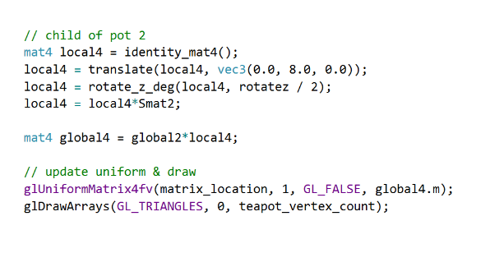
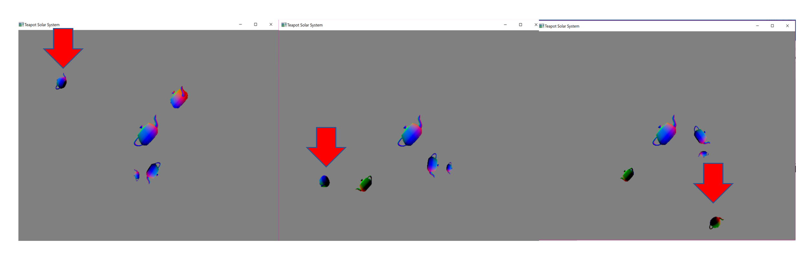
Teapot Number Five
Teapot number five fulfils the one to one requirement of the assignment. It is a child of is teapot number two. They have a one to one relationship. It rotates about teapot twos z axis. It is designed to look like its “moon”.
As a child of pot two its global is gotten by multiplying its local by teapot twos global.


